Create new chatShow chat history
Describe Plant System.vi
Let's talk about Plant System.vi. Here's some information to get you started...
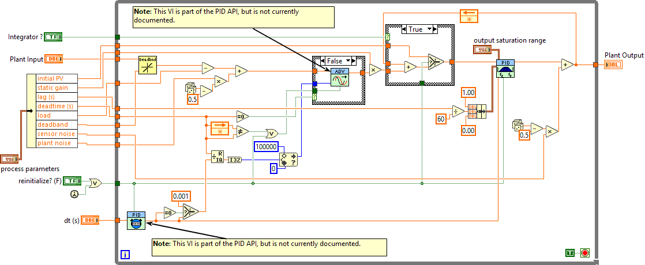
This VI simulates a physical plant’s response for use in feedback control loop testing.

Controls
Name | Default Value | Description
Plant Input | 0 | Controller output in percent; simulates actuator input (e.g., valve or heater control signal).
dt (s) | -1 | Call interval in seconds; if ≤ 0, uses internal timer (1 ms resolution).
reinitialize? (F) | false | If true, reinitializes the output to the current input value.
Integrator ? | false | Enables or disables integrator action in the plant model.
output saturation range | [inf, -inf] | Cluster specifying output high and low limits for plant output saturation.
process parameters | [2.5,2.5,0.001,0,0,0,30,0] | Cluster with: static gain, lag (s), deadtime (s), load, deadband, sensor noise, initial PV, plant noise.

Indicators
Name | Description
Plant Output | Process variable in percent; the simulated measurement you would get from the plant.

How does the VI work?

Initialization and Input Handling
- On first call or when reinitialize? (F) is true, the plant output is set to the current input or initial process value.
- The VI unbundles the process parameters cluster to extract model coefficients (gain, lag, deadtime, etc.).

Timing and Deadtime
- The VI determines the simulation time step (dt (s)). If not provided or ≤ 0, it uses an internal timer.
- Deadtime is simulated using a transport delay buffer, with the delay calculated as a multiple of the loop cycle time.

Plant Dynamics
- The plant model includes:
  - Static gain: Scales the effect of the input.
  - Lag (first-order time constant): Simulates process inertia.
  - Deadtime: Delays the effect of input changes.
  - Load: Adds a constant disturbance.
  - Deadband: Ignores small input changes below a threshold.
  - Integrator: Optionally adds integrating behavior.
  - Noise: Adds random plant and sensor noise for realism.

Output Calculation
- The VI computes the plant’s new output by:
  - Applying deadband and load to the input.
  - Passing the result through a lag filter and optional integrator.
  - Applying deadtime using a buffer.
  - Adding plant and sensor noise (random values scaled by user parameters).
  - Saturating the output to the specified range.

Output
- The final simulated process variable is provided as Plant Output.
- This value can be used as feedback in a closed-loop control simulation.
Tip: You can simulate multiple independent plants by saving copies of this VI under different names. All scale factors are in percent, and lag/deadtime are in seconds. Adjust the process parameters cluster to match your system’s dynamics.Copy Text
Good response
Bad response
Describe this model mathematically to use as a staring point for export to python
Here’s a mathematical description of the plant model implemented in Plant System.vi—ideal for porting to Python:

Plant Model Structure
The VI simulates a first-order lag process with deadtime, load, deadband, optional integrator, and noise. All values are in percent.

Parameters
Symbol | Description | LabVIEW Control/Cluster Element
u | Plant Input (controller output) | Plant Input
dt | Simulation time step (seconds) | dt (s)
K | Static gain | process parameters[0]
τ | Lag time constant (seconds) | process parameters[1]
θ | Deadtime (seconds) | process parameters[2]
L | Load (disturbance, percent) | process parameters[3]
DB | Deadband (percent) | process parameters[4]
σ_s | Sensor noise (percent) | process parameters[5]
PV₀ | Initial process value (percent) | process parameters[6]
σ_p | Plant noise (percent) | process parameters[7]
y_min | Output low limit | output saturation range[1]
y_max | Output high limit | output saturation range[0]

Step-by-Step Model

1. Deadband
If |u - PV| < DB, then u = PV (no change). Otherwise, u is unchanged.

2. Load
Add load:
u₁ = u + L

3. Plant Noise
Add plant noise:
u₂ = u₁ + σ_p × randn()
(randn() is a random value, typically uniform or normal distribution)

4. Deadtime
Delay input by θ seconds (implemented as a buffer of previous values):
u₃ = u₂ delayed by θ

5. First-Order Lag
Discrete-time update:
Let y[n] be the plant output at step n, and u₃[n] the delayed input.
If integrator is off:
y[n+1] = y[n] + (dt/τ) × (u₃[n] - y[n])
If integrator is on:
y[n+1] = y[n] + K × u₃[n] × dt

6. Lead-Lag (optional)
A lead-lag filter may be applied (see PID Lead-Lag VI), but for basic export, you can omit unless needed.

7. Sensor Noise
Add sensor noise:
y₁ = y[n+1] + σ_s × randn()

8. Saturation
Limit output:
y_final = min(max(y₁, y_min), y_max)

Python Pseudocode
# Parameters: K, tau, theta, L, DB, sigma_s, PV0, sigma_p, y_min, y_max, dt
# State: y (plant output), deadtime_buffer (list of previous inputs)

def plant_step(u, y, deadtime_buffer, params, integrator=False):
# Unpack parameters
K, tau, theta, L, DB, sigma_s, PV0, sigma_p, y_min, y_max, dt = params

# Deadband
if abs(u - y) < DB:
u_db = y
else:
u_db = u

# Load
u_load = u_db + L

# Plant noise
u_noise = u_load + sigma_p * np.random.randn()

# Deadtime
deadtime_steps = int(theta / dt)
deadtime_buffer.append(u_noise)
if len(deadtime_buffer) > deadtime_steps:
u_delayed = deadtime_buffer.pop(0)
else:
u_delayed = u_noise # No delay yet

# First-order lag or integrator
if integrator:
y_next = y + K * u_delayed * dt
else:
y_next = y + (dt / tau) * (u_delayed - y)

# Sensor noise
y_sensor = y_next + sigma_s * np.random.randn()

# Saturation
y_final = np.clip(y_sensor, y_min, y_max)

return y_final, deadtime_buffer

Notes
- Deadtime: Use a buffer/list to store previous inputs; output the value from θ seconds ago.
- Integrator: When enabled, the plant output integrates the input (useful for level or position systems).
- Noise: Both plant and sensor noise are added as random values scaled by user parameters.
- Saturation: Output is limited to user-specified range.
This structure matches the LabVIEW VI’s logic and is ready for translation to Python. Adjust the random noise and lead-lag filter as needed for your application. If you need a more detailed mapping (e.g., for the lead-lag filter), let me know!Copy Text

